**THE ARTS CLUB – SIR KARL JENKINS MUSIC AWARD 2019**

**IN ASSOCIATION WITH CLASSIC FM**

We are delighted to announce the fifth competition of our prestigious classical music award, in the wake of this year’s contest which was won by the highly accomplished cellist, Abel Selaocoe.

The panel, chaired by Sir Karl Jenkins, comprises music educationalist, Carol Barratt, chairman of City Music Society, Leslie East, Classic FM presenter, Catherine Bott, managing director of Decca Classical Label Group, Dr. Alexander Buhr and harpist, Catrin Finch, as they seek the most talented instrumentalist in the UK, aged between 18-25.

The winner will be awarded the prize of £4,000 and the opportunity to make a recording of a short repertoire piece of their choosing, as well as a short work especially composed by Sir Karl, to be recorded in a London studio and played on Classic FM. The runner-up will receive a cash prize of £1,000.

Submissions will be reviewed by Sir Karl and Lady Carol (Barratt) in conjunction with a consultation panel of internationally renowned soloists covering every instrumental group: trumpeter Alison Balsom, harpist Catrin Finch, percussionist Dame Evelyn Glennie, clarinettist Emma Johnson and violinist Tasmin Little. Twelve candidates will be chosen to compete in the first live competition round on Saturday 23rd March, where candidates will be judged upon technique, individualism, communication and future potential, leaving just six finalists to perform in the final on Saturday 30th March. Both events will be held at The Arts Club, 40 Dover Street, London, W1S 4NP.

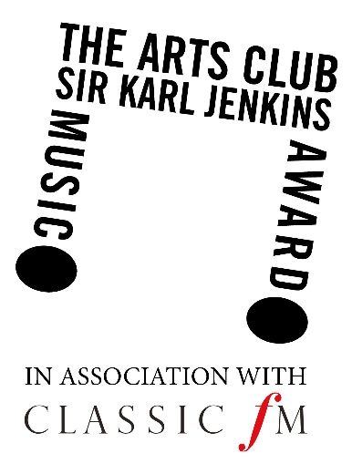



**APPLICATION FORM**

CANDIDATE DETAILS:

First Name(s):___________________________________________________________

 Family Name: ___________________________________________________________

 Address:________________________________________________________________

 Postcode:____________________

 Date of Birth:______/_____/_____

Telephone:____________________

 Email: _________________________________________________________________________

 Music College:______________________________________________________

 Instrument Type:___________________________________________________________

Please provide a summary of your qualifications, training and professional performance as well as the contact details of a professional referee within the arts, should we wish to contact them for a reference. One A4 page of information may be attached to the application.

________________________________________________________________________

_________________________________________________________________________

_________________________________________________________________________

_________________________________________________________________________

_________________________________________________________________________

_________________________________________________________________________

_________________________________________________________________________

_________________________________________________________________________

_________________________________________________________________________



**Terms and Conditions**

To participate, entrants must complete the Application Form and send to [submissions@theartsclub.co.uk](mailto:submissions@theartsclub.co.uk) together with performance submissions not exceeding a total of 12 minutes in duration, which will be accepted by The Arts Club as a link to a YouTube video only. Applicants are to announce the performance pieces on the video, face the audience and not to have music stands or any other objects blocking their face.

Entries must be received by midday GMT on Thursday 7th February 2019.

The candidate must be between the ages of 18-25 years on Saturday 30th March 2019 and must not, at the time of entering and/or during the competition, have signed an exclusive recording agreement in respect of the entrant’s exclusive audio and/or audio visual performance services. The candidate must be studying or have studied in the UK for one year, and still reside within the UK.

Due to restrictions of space and for logistical reasons, we are not accepting applications from pianists. Percussionists should include one ‘tuned’ instrument but be mindful of the fact that, in the event of getting through to the live rounds, there will be restrictions regarding the size of ‘set up’ that can be accommodated.

The candidate must provide their own accompanist if desired.

No application fee or purchase is required.

If successful, the candidate will be required to play two contrasting works (or movements therefrom) in tempo and style, not exceeding a total of 12 minutes in duration for the first public performance on Saturday 23rd March 2019 (which can, but does not have to be, a repeat of the submission piece(s)). If the candidate is successful in the first round, the requirements for the final on Saturday 30th March 2019 are two or three contrasting works (or movements therefrom) in tempo and style, which must be different to those heard in the first round, not exceeding a total of 15mins in duration.

The winner will be awarded the prize of £4,000 by cheque. In addition, a piece from the winner’s competition repertoire as well as a short work especially composed by Karl, will be recorded in a London studio and subsequently broadcast on Classic FM. The runner-up will receive a cash prize of £1,000 by cheque. The winner will be announced following the performances of all finalists on Saturday 30th March 2019.

The panel of judges will select a winner based upon technique, individualism, communication and future potential. The choice of winner will be final and binding on the entrants; no correspondence will be entered into.

By entering this competition, the subsequent winner and finalists agree to allow the free use of their names and likenesses for publicity and news purposes during this and future promotions by The Arts Club and Classic FM. Names of the winners may be published on The Arts Club, Classic FM and panellists’ websites.

All intellectual property in and to recordings submitted for the purposes of this competition and owned and/or controlled by entrant shall remain vested in the entrant save that entrant hereby grants to Sir Karl Jenkins a non-exclusive, royalty free, perpetual, worldwide licence to use such recordings by all means and in all media for promotional purposes related to the competition.

By entering this competition, entrants are deemed to have accepted and be bound by these Terms and Conditions, if they do not adhere to the terms and conditions they could face being disqualified. These Terms and Conditions shall be governed by English law and the courts of England and Wales shall have exclusive jurisdiction.